PROJECT

BIOgen

HEART

**a HEART FOR**

**THOUSAND HEARTS**

******A small beat can save millions of people.**

**PRESENTED BY ESCI AND VMVHS.**

**OBJECTIVE**: - To bring in significant awareness over the project BIOgen HEART.

**SUBJECTIVE ANALYSIS**: - To provide external support with secondary tissue respiration and also provide rich OXYGEN without free radicals and to avoid major disorders.

**AIM**: - To remove free radicals which are the main culprits which produce various disorders starting from metabolic disorders to malignancies and also cardiac disorders.

**PRIME SUBJECT**: - A biogenic heart will be made from human stem cells and will be reshaped into tiny heart, with the same functions of the normal heart. It is a device fitted inside very easily and will perform the functions of both heart and lungs. This is new invention and remains one of the most sought after goals of modern medicine. The benefits will be immense and through our statistical data analysis it is found that the BIOgen heart may help the patients to overcome the major disorders.

**KEY ELEMENTS OF BIOgen HEART**

It begins with a donor or a patient’s own stem cells being taken and ends with 3D Bio printed heart which is fit for deployment into the body.

**STEPS:-**

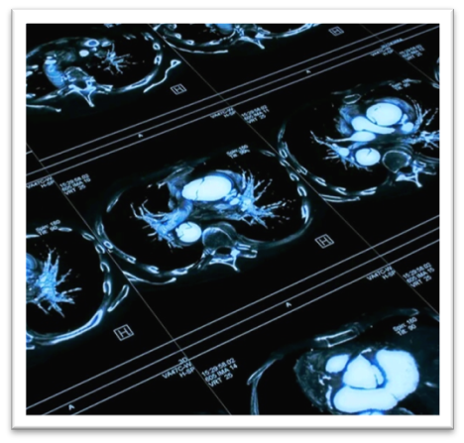

1. A MRI scan would be performed and a blood sample is collected from the patient by using G-factors.

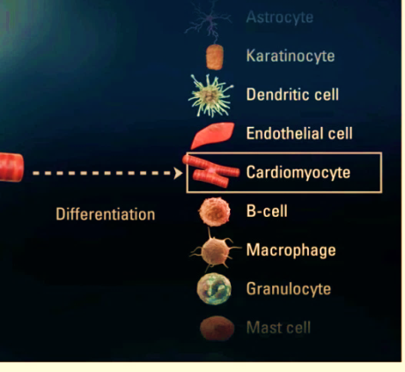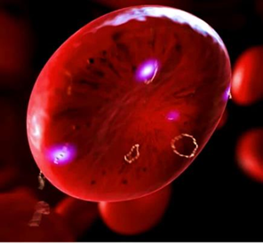

1. The blood cells from the sample will be converted to induce pluripotent stem cells (PSC’s), which will change into cardiomyocytes (Heart cells). This process is called as differentiation. These cells 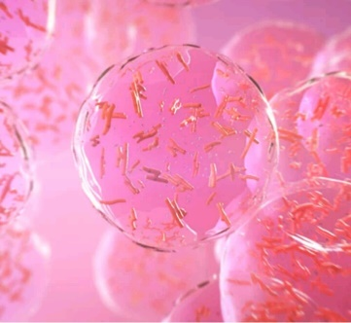(cardiomyocytes) will be combined with nutrients in a liquid environment (HYDROGEL), to keep the cells alive and in return will turn into BIO-INK. This bio-ink made of living cells, will be sustained in the aqueous 3D environment.
2. 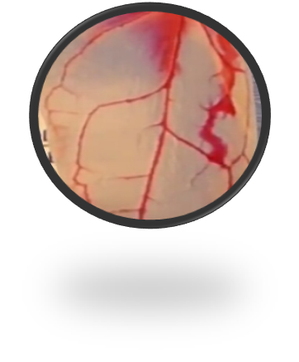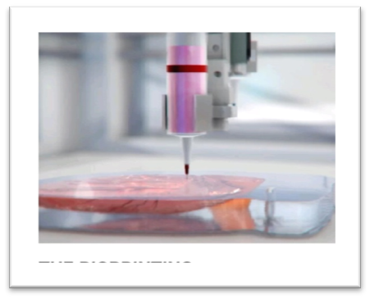This bio-ink will be then loaded into a BIOPRINTER. An appropriate sized heart (6 to 10mm), will be then printed in the form of a single layer at a time, guided by CAD (computer software) following the specific dimensions obtained from the MRI with the help of DICOM. As heart cells will not be fused together a biocompatible SCAFFOLD like spinach leaf will be adhered to support the cells and hold them. After completion of the process this BIOgen heart will be moved to a BIO- REACTOR which will mimic the nutrient and oxygen rich conditions within the human body.
3. 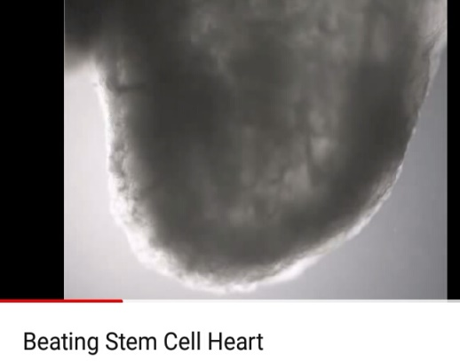The individual cells will begin to self-organize and fuse into a network and will start to beat.
4. Once the process is over the scaffold will be dissolved leaving only the fully formed miniature heart and will remain in the bioreactor until it reaches maturity.
5. Deployment of matured miniature heart in the body is done in a place which is in the form of a cushion and has a cushion like aponeurosis. This deployment is done by CT or vascular surgeons by using minimal anesthesia and glue is used in place of sutures. The new heart which is made should be precisely fit and also be a genetic match to the patient, and free from the risk of rejection or any from the need of immunosuppressant therapy.
6. After post deployment phase the assessors and the analyzers present in the committee headed by super specialists of all faculties will validate in a phasic form and mark the results to know the outcome.

CORE OPERATIONAL TEAM

1) Mr. Jagadish Lolugu – Project Director, Project BIOgen Heart – ESCI.

CONTACT DETAILS:

M- 09985506705

E –dpc@escihyd.org

2) Dr.Vedala Ramakrishna - Medical Director, Project BIOgen Heart – VMVHS.

CONTACT DETAILS:

M- 8919253085

E- Ramakrishna.vedala10@gmail.com

3) Dr.Vedala Ranga Chary – Chief Medical Researcher, Project BIOgen Heart- VMVHS.

CONTACT DETAILS:

M- 9247258915

E- Vedalarangachary28@gmail.com

Vmvhealthcare@gmail.com

4) Dr. Shruti Vedala – Consultant for Project BIOgen Heart –VMVHS.

CONTACT DETAILS

M- 6301003250(India), +978-826-8740( USA)

E –vshruti.chary@gmail.com